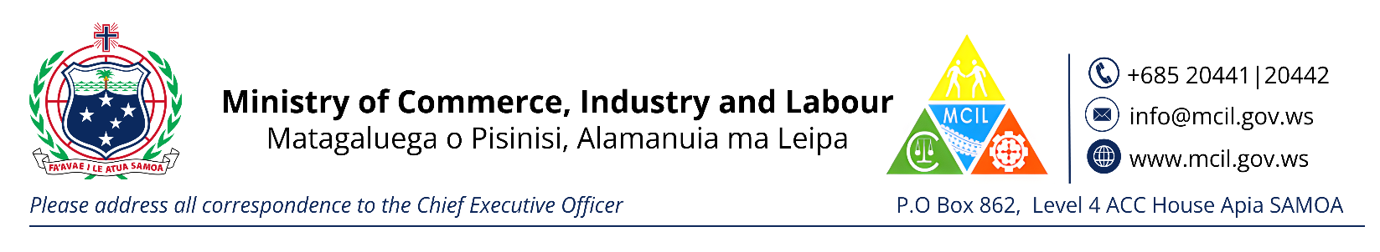**CHECKLIST FOR REGISTRATION OF AN OVERSEAS COMPANY**

Evidence of Incorporation overseas \****Certified if Copy *Translate to English if it’s in different language***

Evidence of Rules of Incorporation overseas * ***Certified if Copy *Translate to English if it’s in different language***

Confirmation from Samoa Post Office of a registered Postal Box * ***or confirmation of postal box of the authorized person***

Directors I.D (copy of current passport or Driver’s License)

Fee - $300.00