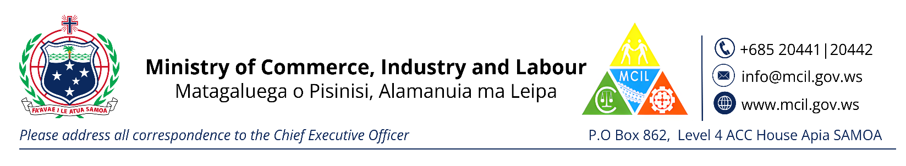**CHECKLIST FOR REGISTRATION OF A NEW COMPANY**

Directors Consent (Form 2)

Confirmation from Samoa Post Office of a registered Postal Box

Directors I.D (copy of current passport or Driver’s License)

Fee - $250.00

Website: www.businessregistries.gov.ws