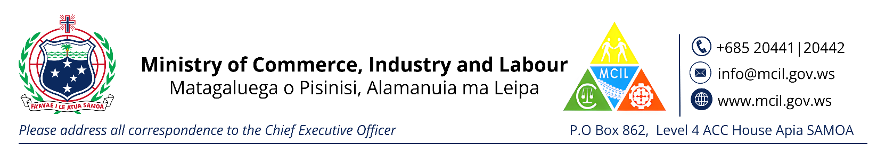
CHECKLIST FOR REGISTRATION OF AN OVERSEAS COMPANY
Evidence of Incorporation overseas *Certified if Copy *Translate to English if it’s in different language
Evidence of Rules of Incorporation overseas * Certified if Copy *Translate to English if it’s in different language
Confirmation from Samoa Post Office of a registered Postal Box * or confirmation of postal box of the authorized person
Directors I.D (copy of current passport or Driver’s License)
Fee - $300.00

